Assignment: Switching and VLANS

1. VLAN Network Diagram
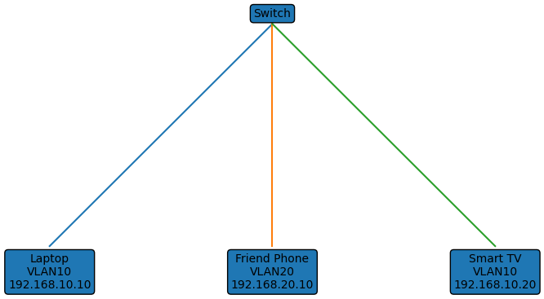

2. Create VLANs
enable
configure terminal
vlan 10
name STREAMING
vlan 20
name PERSONAL
interface range fa0/1-3
switchport mode access
switchport access vlan 10
interface range fa0/4-5
switchport mode access
switchport access vlan 20
After configuration, PCs in different VLANs cannot ping each other without inter-VLAN routing.

3. Move PC from VLAN 10 to VLAN 20
Before:
interface fa0/3
switchport access vlan 10
After:
interface fa0/3
switchport access vlan 20
Verify using ping. The PC can communicate with VLAN 20 devices but not VLAN 10 devices.

4. Automate Port Assignment
configure terminal
vlan 30
name LAB
interface range fa0/1-10
switchport mode access
switchport access vlan 30
end
write memory

